Energy management system in solar powered applications

The system typically consists of Energy source (Solar panels) and standardized energy storage modules consisting of either high power(HP) or High energy (HE) devices or combined along with the Master control unit and Power distribution unit.

Solar panels are used as energy source and Li-ion battery with specific configuration is chosen as Energy Storage system (ESS). Different types of ESS, in addition to batteries, such as Electrical double layer capacitors (EDLC) can be incorporated as well.

Most propulsion systems and subsystems used in mobility applications are sized for their operating point (typically, the point in which the transportation vehicle operates for the most duration during the mission). This appears to be the best strategy for single energy source vehicles, but with the advent of electric mobility and multiple energy sources/storage systems for achieving electric propulsion, there is tremendous scope to improve the energy usage over the entire operating envelope.For efficient use of energy available, the load must be able to utilize the energy from the two or more sources in an optimal manner.

The following cases are possible in solar powered vehicles

Case1:

When sufficient power is generated by solar panel; the power flow must be completely towards the load.,In case of excess power generation by the solar panel, the excess power is utilized in charging the battery.

Case 2:

When the solar power generated is very very less compared to required, the load power requirement is met from the battery.

Case 3:

When power from solar cell is adequate but not sufficient enough to meet entire load demand, the load requirement is met by utilizing both solar and batteryl. In this scenario,the system must be able to switch between the above configurations

A topology of the Hybrid energy storage system needs to be chosen while keeping in mind the battery charging configuration. Since the load is controlled using a control unit (flight controller) , it eliminates the need for an extra power converter. Therefore, a passive energy storage topology is chosen along with a Solar charger sub-system which includes a Battery charge controller with MPPT.

The battery charge controller is a buck-boost switching regulator battery charger that implements a constant-current constant-voltage (CCCV) charging profile used for battery types such as Li-ion. The device operates from input voltages above, below or equal to the output voltage and is powered by solar panel.

A Master Control Unit ,acquires data from the current and voltage sensors and sends the control signals to the switching circuitry based on the inputs obtained and load requirements.

A power distribution unit then distributes the power to different loads.

Low-level component control includes connection of energy storage systems along with dc-dc converters and sensors linked with them.An Intelligent control algorithm will decide the optimum use of power.

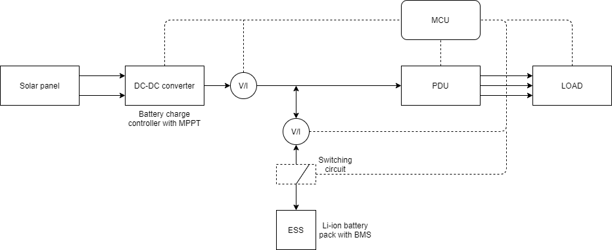

Fig. 1.1 Basic configuration of the energy management system

The energy produced by the PV panels varies with respect to time of the day and many external factors such as passing of clouds, etc., The regular approach would be to monitor the sensor readings for power input from solar and set a threshold limit. If there is a situation where the solar input is not sufficient to meet the load requirements and the input from the solar is below the set threshold, it is recommended to disconnect the battery charging process and discharge the battery. During this stage, it is recommended to operate the vehicle in a lower power state.Once the solar power goes above the threshold the battery charging process is reset.

If the duration of solar power outage is very short, considerable switching is not required. Monitoring and forecasting of the solar radiation is required to prevent this switching process inorder to lessen the stress on the battery.

Machine learning techniques can be used to increase the accuracy of solar forecasts compared to the traditional methods. Self learning weather model and renewable forecasting (SMT) increases the accuracy of solar forecasting by over 30% when compared to currently available weather forecast models.[2]

Further as the complexity of the system increases, wherein more number of Energy storage systems are employed ,topology changes with inclusion of power electronic converters and switching elements.

The new topology may be active, semi-active or discrete hybrid[1].

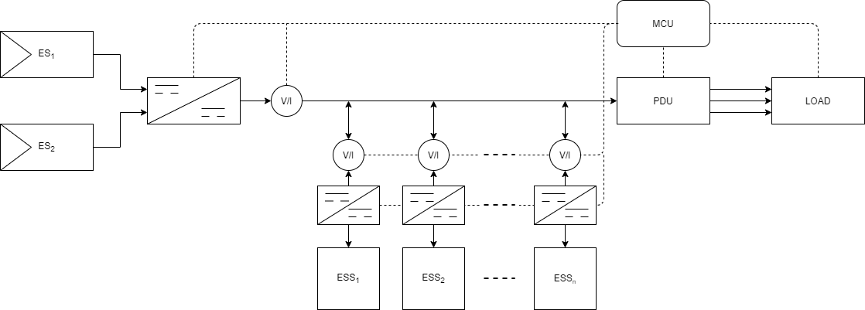

Fig 1.2 Block diagram of EMS with multiple Energy Source(ES) along with multiple Energy Storage system(ESS)

The advantage of adding multiple hybrid storage systems is an overall increase in specific power and/or specific energy. High power storage elements enable acceleration or deceleration of power. In contrast High-energy storage elements ensures the long-term supply and in general realized using Li-ion cells. In case of multiple Energy storage systems , several factors need to be considered in deciding which is the best source to be utilized. These factors vary from time, temperature,nature of load,charge/discharge characteristics etc.,

In order to increase the source efficiency and power quality an active distribution of power flow is necessary , where the storage units are coupled with a dc-dc converter. The controlling of these units can be done using several techniques such as PID based control strategy or fuzzy based approach. Any of the Optimization control technique can be implemented to effectively switch between the sources and the storage elements

Optimization control is divided into global optimization and real-time optimization (RTO) methods. There are lots of strategies under each subdivision of Rule Based and optimization-based control. Few examples are Linear programming ,genetic algorithm, adaptive fuzzy RB,Neural network, Model predictive control etc.,[3] Factors such as computational time,structural complexity,type of solution and requirement of prior knowledge need to be considered in selecting the right strategy.Using these modern techniques will improve the system stability, increase the efficiency as well as extend the battery lifetime.

*[1]JES Review of system topologies for hybrid electrical energy storage systems*

*[2]Baseline and target values for regional and point PV power forecasts: Toward improved solar forecasting*

*[3]A Review of Energy Management System in Battery Electric Vehicle with Hybrid Electrical Energy Source*